CREATE DATABASE ORG123;
SHOW DATABASES;
USE ORG123;

CREATE TABLE Worker (
WORKER_ID INT NOT NULL PRIMARY KEY AUTO_INCREMENT,
FIRST_NAME CHAR(25),
LAST_NAME CHAR(25),
SALARY INT(15),
JOINING_DATE DATETIME,
DEPARTMENT CHAR(25)
);

INSERT INTO Worker
(WORKER_ID, FIRST_NAME, LAST_NAME, SALARY, JOINING_DATE, DEPARTMENT) VALUES
(001, 'Monika', 'Arora', 100000, '14-02-20 09.00.00', 'HR'),
(002, 'Niharika', 'Verma', 80000, '14-06-11 09.00.00', 'Admin'),
(003, 'Vishal', 'Singhal', 300000, '14-02-20 09.00.00', 'HR'),
(004, 'Amitabh', 'Singh', 500000, '14-02-20 09.00.00', 'Admin'),
(005, 'Vivek', 'Bhati', 500000, '14-06-11 09.00.00', 'Admin'),
(006, 'Vipul', 'Diwan', 200000, '14-06-11 09.00.00', 'Account'),
(007, 'Satish', 'Kumar', 75000, '14-01-20 09.00.00', 'Account'),
(008, 'Geetika', 'Chauhan', 90000, '14-04-11 09.00.00', 'Admin');

Write SQL queries to:
- Display all workers whose salary is greater than 1,00,000.
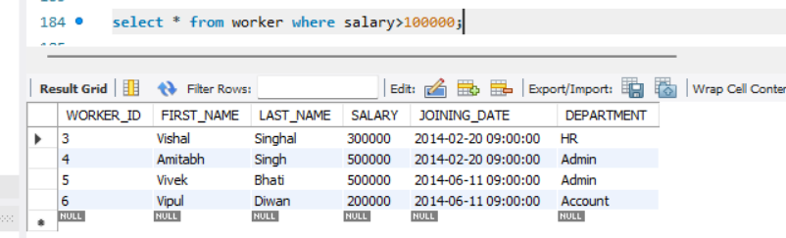
- Display workers whose salary is less than or equal to 90,000.
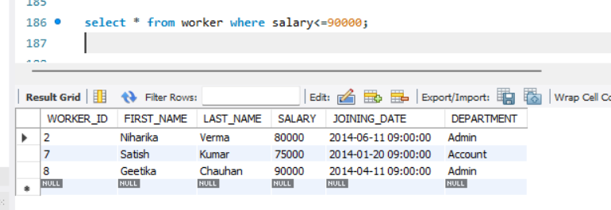
- Display workers whose salary is greater than or equal to 3,00,000.
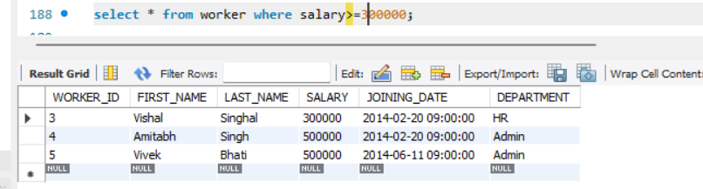
Task 2: Logical Operators (AND, OR, NOT)

Write SQL queries to:
- Display workers who belong to the HR department and earn more than 1,00,000.
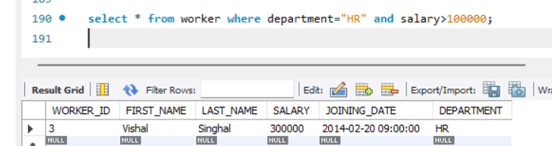

- Display workers who belong to either the Admin or Account department.

select * from worker where department="Admin" or department="Account";
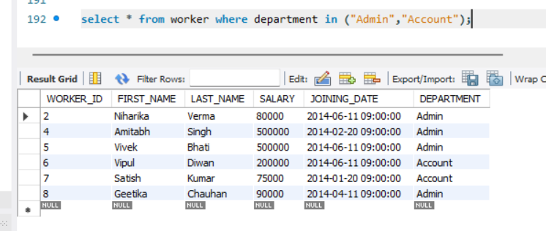
- Display workers who do not belong to the HR department.

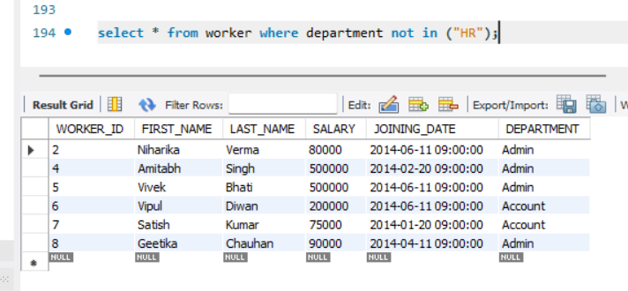
Task 3: Special Operators (IN, BETWEEN, LIKE)

Write SQL queries to:
1. Display workers whose department is either HR, Admin, or Account using IN.

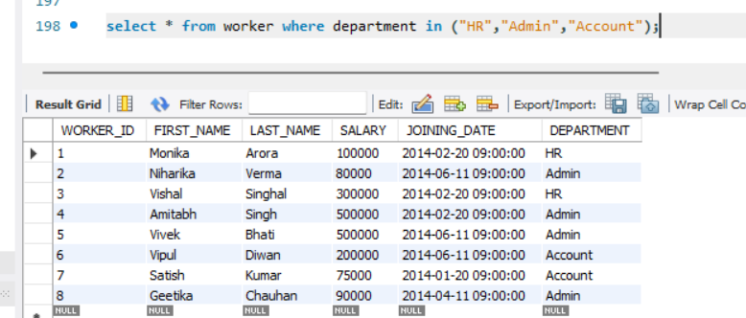

2. Display workers whose salary is between 80,000 and 3,00,000 using BETWEEN.
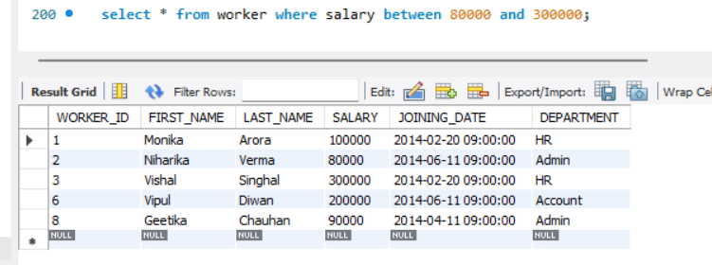
- Display workers whose first name starts with the letter 'V' using LIKE.
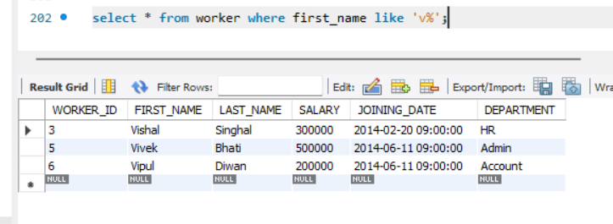
- Display workers whose last name ends with 'a' using LIKE.
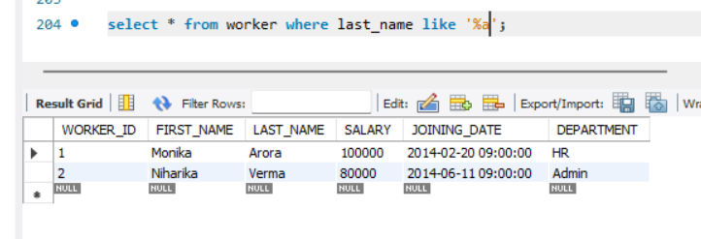

Order

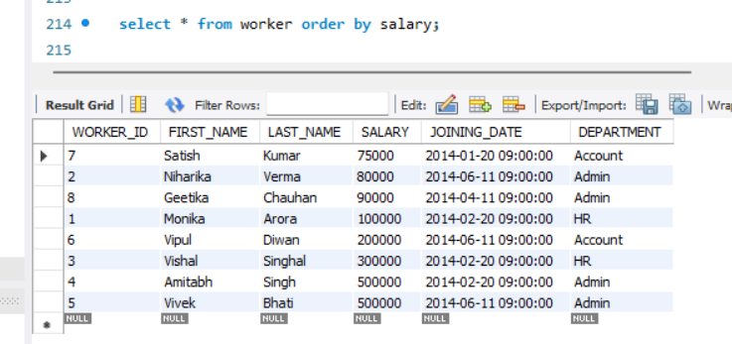

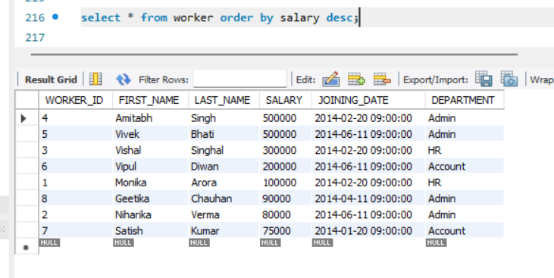

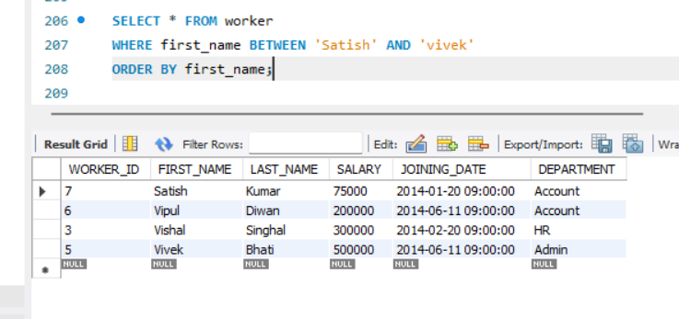

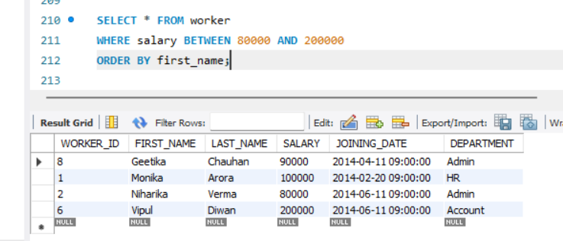

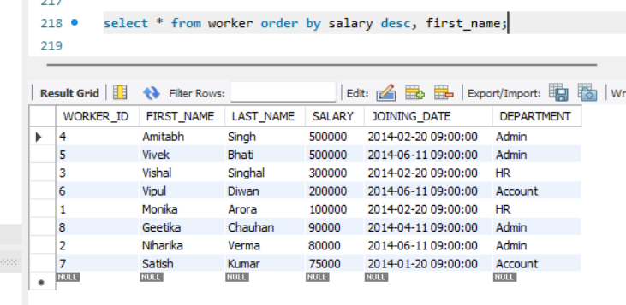

Display the department-wise total salary in descending order.
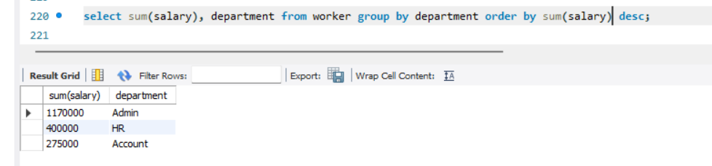

Display the department-wise average salary in ascending order.

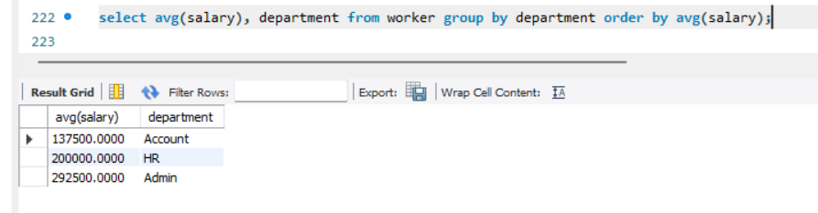

Display the number of workers in each department, sorted by worker count in descending order.
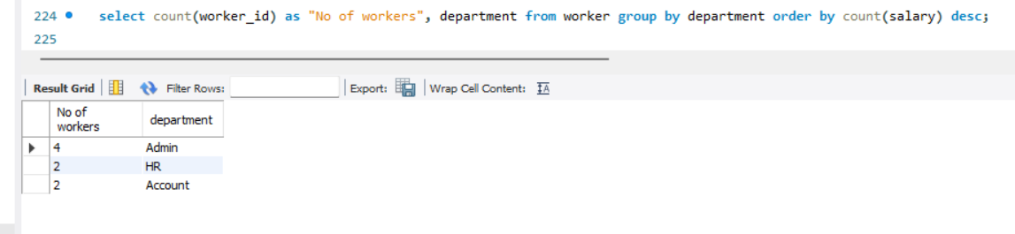

Display the minimum salary of each department, sorted from lowest to highest.

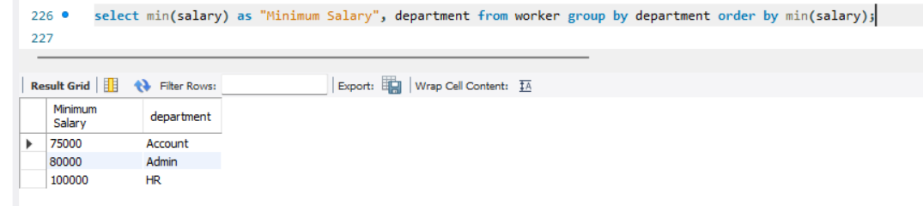

Display each department with its total workers, maximum salary, and minimum salary.

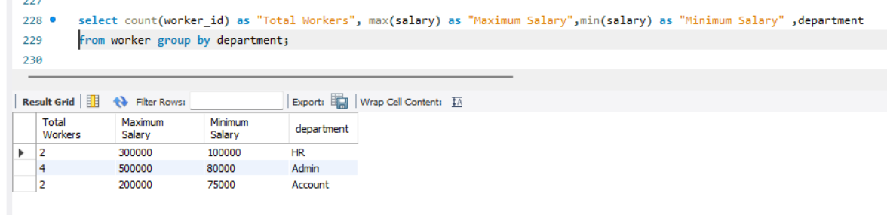

Display each department with its total salary and average salary.

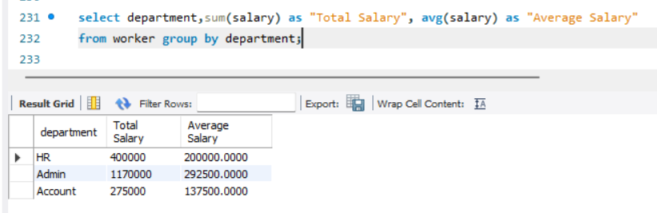

Display each department with its total workers and average salary, sorted by average salary in descending order.

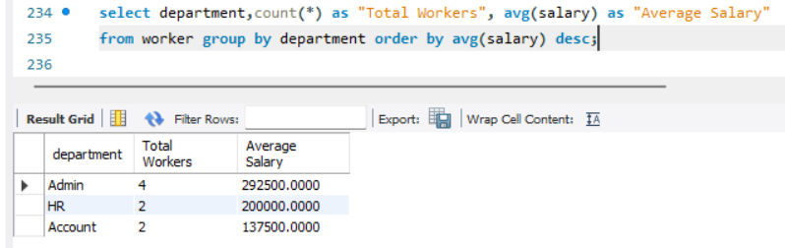

Display each department with its highest salary and lowest salary, sorted by highest salary in descending order.

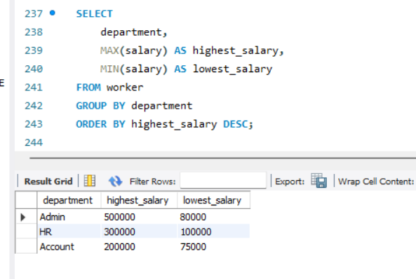

Having



